

RURAL TRANSIT AGENCY

CAPITAL IMPROVEMENT PLAN (CIP) MANUAL



# Introduction

Capital Improvement Planning (CIP) is essential to operating a successful Transit Agency. The best CIP processes integrate human services and other community service needs. This manual is a workbook and guide for developing your CIP. Transit capital assets include three categories, as listed below:

1. Rolling stock such as buses and vans
2. Facilities
3. Equipment and Technology such as vehicle lifts, diagnostic equipment, and hardware/software.

Assets are funded through various local sources such as farebox revenues, state and federal grant programs, and donations. The basic documentation commonly used in creating a CIP is detailed in the diagram below.

**Urban**

* Urban planning done by metropolitan planning organizations (MPOs).
* Established Requirements and processes.

**Rural Transit Systems**

* Coordinated Human Service Transportation Plan
* State Transportation Improvement Program (STIP)
* Transit Service Plan
* Public Transportation Agency Safety Plan (PTASP)
* Transit Asset Management Plan (TAM)
* Transit Technology Plan

**Project Planning and Programming**

* Capital Improvement Plan (CIP)
  + Rolling Stock
  + New Facilities and Remodel Projects
  + Equipment and Technology
  + Budget

Your finalized CIP contains three parts – identifying needs, creating a budget, and finalizing the plan. This manual will give you a step-by-step process for completing those three parts and a workspace to write notes and ideas to help create the final plan.

# Why is a CIP important?

A sound and well-designed program of capital investments can provide a transit system with many benefits, including improved system reliability, reduced operating costs, and increased ridership and farebox revenues. A successful CIP results from a process that identifies needs, assesses funding availability and resources, and prioritizes investments.

Careful consideration of future investments will allow transit agencies to fund and sustain long-term capital investments. This plan should be based on the vision for transit within your community(s), knowledge of historical and current operating budget, system performance and awareness of the market forces and trends that will influence transit in the future.

The more your transit agency is visible and active in the community, the more successful it will be at garnering support and financial resources for its capital program. Combined with the proper planning tools, these best practices can help transit agencies develop a capital program that meets current and future needs.

# Step 1: Identifying Needs

1. Create a list of capital needs - Focus on achieving and maintaining your assets’ State of Good Repair for a safer and more reliable transit fleet.
2. Use asset management software to assist in identifying future needs. Information can be found in current SDDOT software by reviewing your assets’ condition ratings calculated by your agency and SDDOT staff.
3. Rank capital needs based on priority. One is the highest priority.
4. Review capital needs to determine benefits, potential obstacles, and community support.

In the text boxes throughout the manual, describe and prioritize your agency’s current and future needs. Detailed description and background knowledge will help fill out your current CIP and be a helpful reference when you complete your future CIPs. Remember to consider the benefits, obstacles, maintenance costs and community support your agency has for each need.

In the text box below, describe and prioritize your agency’s current and future rolling stock needs. Detailed description and background knowledge will help fill out your current CIP and be a helpful reference when you complete your future CIPs. Remember to consider the benefits, obstacles, preventative maintenance costs, and community support your agency has for your rolling stock needs.

**Rolling Stock Text Box**

|  |
| --- |
|  |

**Rolling Stock Tab**: The first tab of the CIP template is to identify your rolling stock needs. Enter the number of replacement vehicles– document the last six of the vehicles’ VIN numbers for the vehicles you are replacing and the priority ranking. enter the number of expansion vehicles and the corresponding priority ranking. Enter the total dollar amount for each vehicle category. Enter all associated preventative maintenance costs. You will notice different vehicle types on the spreadsheet’s left side, including ADA minivans, non-ADA minivans, passenger vans, sedans/SUVs, narrow-body buses, cutaway buses and rolling stock preventative maintenance. Please enter the vehicle information according to each vehicle type. The information from the rolling stock text box above will help with the details needed for the facility tab.

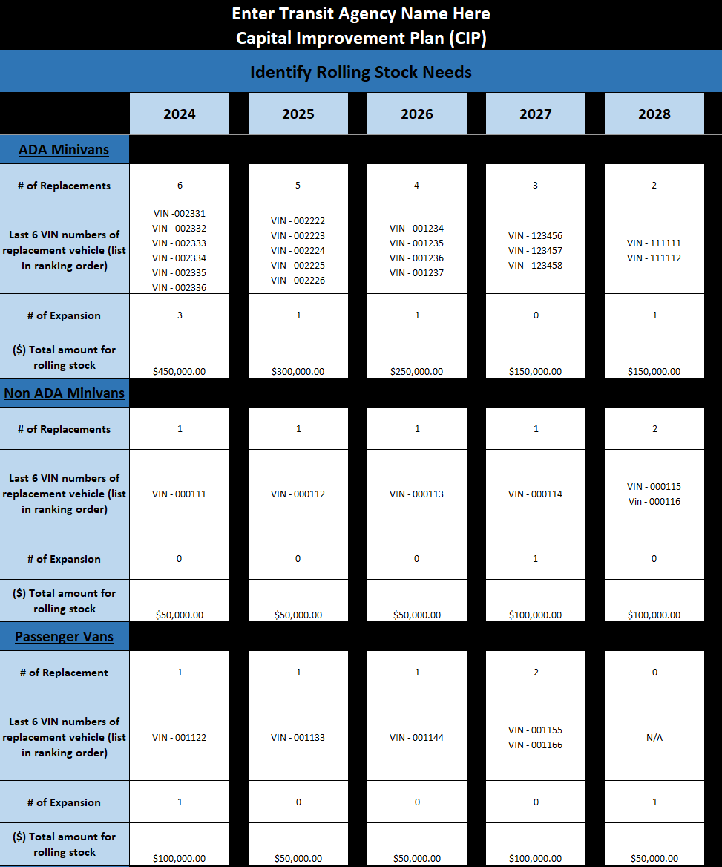

In the text box below, describe and prioritize your agency’s current and future facility needs in the text box below. Detailed description and background knowledge will help fill out your current CIP and be a useful reference when you complete your future CIPs. Remember to consider the benefits, obstacles, maintenance costs and community support your agency has for each need.

**Facility Text Box**

|  |
| --- |
|  |

**Facility Tab:** The second tab of your CIP template is for Identifying Facility Needs.

Please enter the project location, description, cost amount, facility preventative maintenance, and all associated preventative maintenance costs. The information from the facility text box above will help with the details needed for the facility tab.

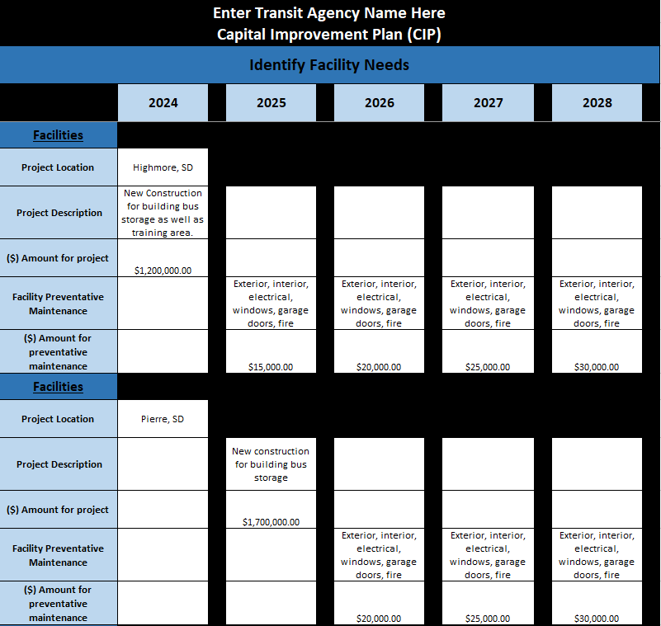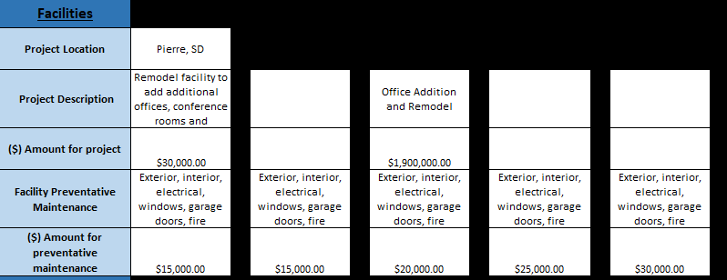

In the text box below, describe and prioritize your agency’s current and future equipment needs in the text box below. Detailed description and background knowledge will help fill out your current CIP and be a useful reference when you complete your future CIPs. Remember to consider the benefits, obstacles, maintenance costs and community support your agency has for each need.

**Equipment Text Box**

|  |
| --- |
|  |

**Equipment Tab:** The third tab in your CIP will identify equipment needs. The spreadsheet is categorized along the left side of the spreadsheet by equipment, technology, and miscellaneous. Enter all associated preventative maintenance costs at the bottom of the spreadsheet. The information from the equipment text box above will help with the details needed for the facility tab.

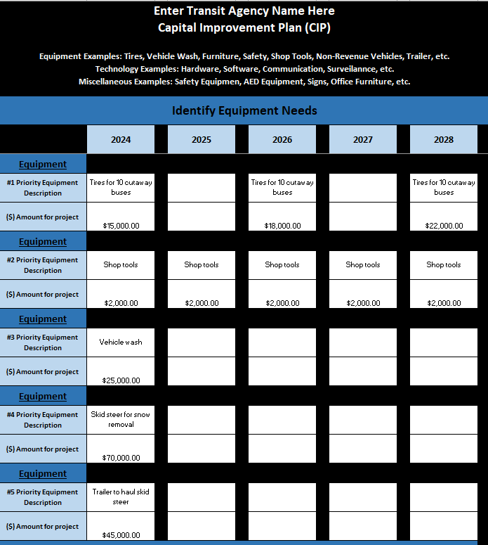

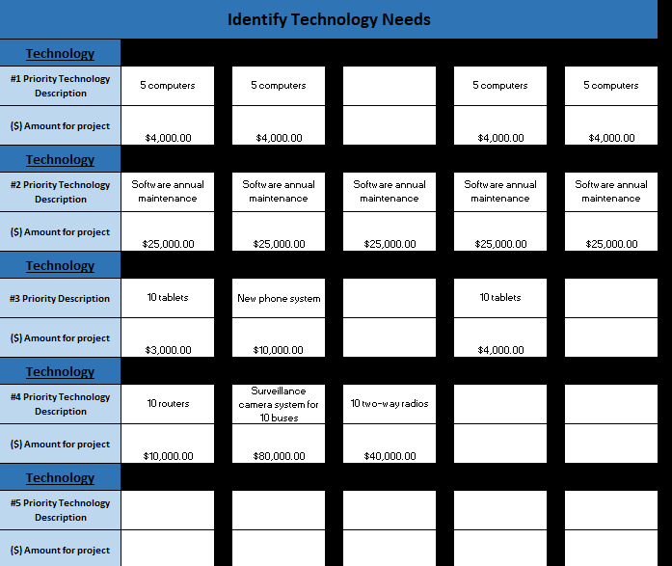

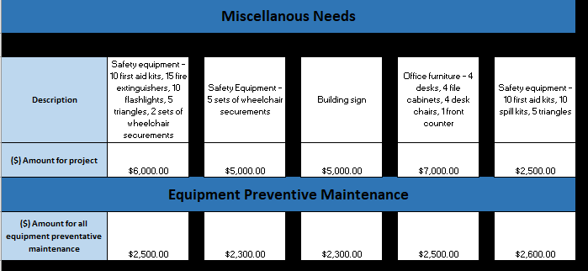

# Step 2: Budget

Comparing funds available with funds needed will enable you to identify funding overages or shortfalls and begin planning. Remember to consider the estimated overall cost of each project, estimated operational & maintenance costs for each project, total revenues from each project, and funding sources needed.

Summarize your agency's current and future budget in the text box below. You can accomplish this by asking yourself the following questions:

* How much 5339(a) funds are historically available for my transit agency?
* How much 5339(b) competitive funds are typically available for my transit agency? Which assets do I want to target using discretionary funds?
* How much funding from donations can I expect from the communities we serve? Can we use these donations for asset acquisition?
* What additional and innovative funding mechanisms can we target? When do these additional opportunities become available for application?

|  |
| --- |
|  |

**Budget:** The fourth tab of the CIP template will create a budget. The budget tab will determine the financial requirements needed to support the CIP. The spreadsheet includes 5339/5310, 5304, and 5311 administrative and operating. The information from the budget text box above will help with the details needed for the budget tab.

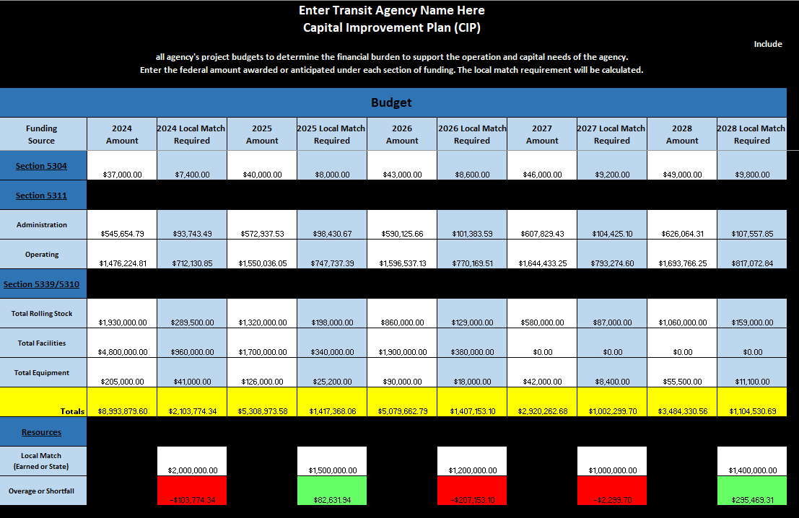

# Step 3: Final Plan

The final tab will be auto formulated, summarizing the needs assessment, the project prioritization, the evaluation of funding options, and providing an annual schedule for implementing projects in the future.

**On the next page is an example of a Finalized Plan**



